Lab: Data Types and Variables
Problems for exercise and homework for the Python Fundamentals Course @SoftUni.
Submit your solutions in the SoftUni judge system at https://judge.softuni.org/Contests/1721.

Concat Names
Write a program that reads two names and a delimiter. It should print the names joined by the delimiter.

Examples
Input | Output
John  Smith  -> | John->Smith
Jan  White  <-> | Jan<->White
Linda  Terry  => | Linda=>Terry

Hints
- Read the data:
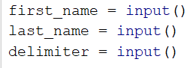
- Print:

Convert Meters to Kilometers
You will be given an integer that represents a distance in meters. Write a program that converts meters to kilometers formatted to the second decimal point.

Examples
Input | Output
1852 | 1.85
798 | 0.80

Hints
- First, we read the input number:
- Then, we convert it to km:
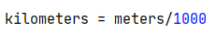
- Finally, print the number formatted to the second decimal point:
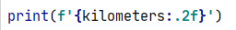

Pounds to Dollars
Write a program that converts British pounds (integer) to US dollars formatted to the 3rd decimal point.
1 British Pound = 1.31 Dollars.

Examples
Input | Output
80 | 104.800
39 | 51.090

Hints
- Read the pounds:
- Convert them to dollars:
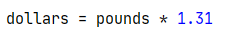
- Finally, print the number formatted to the third decimal point:
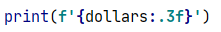

Centuries to Minutes
Write a program that reads an integer number of centuries and converts it to years, days, hours, and minutes.

Examples
Input | Output
1 | 1 centuries = 100 years = 36524 days = 876576 hours = 52594560 minutes
5 | 5 centuries = 500 years = 182621 days = 4382904 hours = 262974240 minutes

Hints
- Assume that one year has 365.2422 days on average (the Tropical year).

Special Numbers
Write a program that reads an integer n. Then, for all numbers in the range [1, n], prints the number and if it is special or not (True / False). A number is special when the sum of its digits is 5, 7, or 11.

Examples
Input | Output
15 | 1 -> False  2 -> False  3 -> False  4 -> False  5 -> True  6 -> False  7 -> True  8 -> False  9 -> False  10 -> False  11 -> False  12 -> False  13 -> False  14 -> True  15 -> False
6 | 1 -> False  2 -> False  3 -> False  4 -> False  5 -> True  6 -> False

Hints
- First, we read the data:
- Iterate from 1 to n (we write n+1 because the for loop in Python iterates from 1 to n-1 by default):
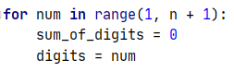
- To calculate the sum of digits of given number num, you might repeat the following: sum the last digit
(num % 10) and remove it (sum = sum / 10) until num reaches 0.
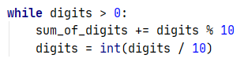
- Finally, print the result:
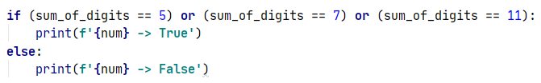

Next Happy Year
You are saying goodbye to your best friend: "See you next happy year". Happy Year is the year with only distinct digits, for example, 2018. Write a program that receives an integer number and finds the next happy year.

Examples
Input | Output
8989 | 9012
1001 | 1023

